**Port du masque obligatoire**

[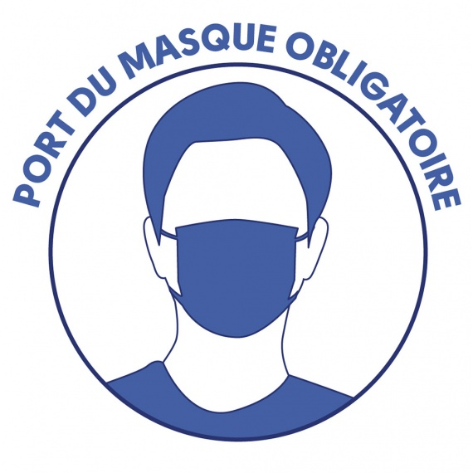](https://www.google.com/url?sa=i&url=https://www.sainthilairederiez.fr/actualites/obligation-du-port-dun-masque-dans-les-marches-forains-et-les-supermrches/&psig=AOvVaw2-Pux933y6smPU-6VsynsX&ust=1595053399802000&source=images&cd=vfe&ved=0CAIQjRxqFwoTCMDj54vT0-oCFQAAAAAdAAAAABAP)